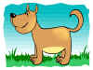February 20th 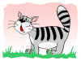 “Love Your Pet Day”
IDEAS
- Make a portrait of your real or fantasy pet:
(poster, photo, collage, painting)
- Write a story about your real or fantasy pet.
- Make or draw them new toys.
- Draw or create your pet’s house.
- Make a crossword.
- Create a ”Pets’ ABC” 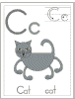
or “Farm Animals’ ABC” 