Проверочная работа на знание активной лексики по теме «Магазин. Покупки»
We often buy food in the __1__ shop because it is next to our house. We don’t go for meat to the __2_and for fish to the _3__. We buy them in the indoor __4__. Sometimes we buy sweets and cakes in the __5__. My little sister likes milk and I go to the __6__ every day. We don’t buy vegetables in the __7__ or flowers in the __8__ because we have a garden.
My Granny sees badly, she goes to the __9_ for eye-glasses. When I need pens, pencils, copy-books for school I go to the __10__.
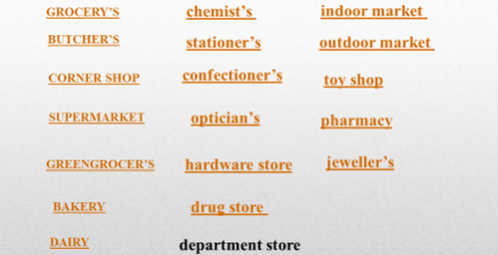
Проверочная работа по теме «Количественные местоимения»
№1
Выбери much или many; добавь окончание множественного числа, где возможно.
1. … tea.. 2. … bread… 3. … dress.. 4. … jacket…
№2
Выбери a little или a few; добавь окончание множественного числа, где возможно.
1. … poltry… 2. … can… of Pepsi 3. … water… 4. … glass… of water…
№3
Выбери How much или How many; добавь окончание множественного числа, где возможно.
1. … jam have you got? 2. … cup… of coffee have had? 3. … slice… of pizza would you like? 4. …butter… do you have for breakfast?

Контроль лексики и грамматики по теме «Магазин.Покупки»

1 вариант №1
Pharmacy/corner shop/dairy/greengrocer’s/bakery
1. I go to the__to buy bread. 2. We needed some potatoes that’s why I went to the__. 3. My granny works in a ___ shop that is in our house. 4. We don’t go to the __ because our family has got a cow.
5. She visited a __ to buy vitamins for her baby.
№2
Much/many/ a little/little/ a few/few
1. I have got _ money. It’s enough to pay for my breakfast. 2. How __ sisters have you got? 3. Jane can’t cook soup. She has got __ potatoes. 4. I didn’t go to school yesterday. There was __ snow in the street.

2 вариант №1
Drug store/butcher’s/stationer’s/grocer’s/bakery
1. I go to the__to buy bread. 2. We needed some flour that’s why I went to the__. 3. My grandad works in a ___ where you can buy meet. 4 She visited a __ to buy vitamins for her baby. 5. I have bought this pen in the __ .
№2
Much/many/ a little/little/ a few/few
1. How __ sugar do we have? 2. There are __eggs. I can make a cake. 3. How _ friends will come to your birthday? __ : 2 or 3. 4. There is ___ water in the bottle but I want to drink very much.

3 вариант

№1
1. I buy grain bread in the __. 2. I went to the__ to buy some vegetables 3. My friend works in a ___ where you can buy fresh poultry. 4 She visited a __ to buy vitamins for her sister. 5. I can buy food and clothes in a __ .
№2
Much/many/ a little/little/ a few/few
1. Let’s go shopping. There is __ food at home. 2. My Granny has got ___ flowers in the yard. 3. She’s written __ SMS today: 5 or 6 ones. 4. We’ve got __ coffee in the jar. We opened it in the morning.

