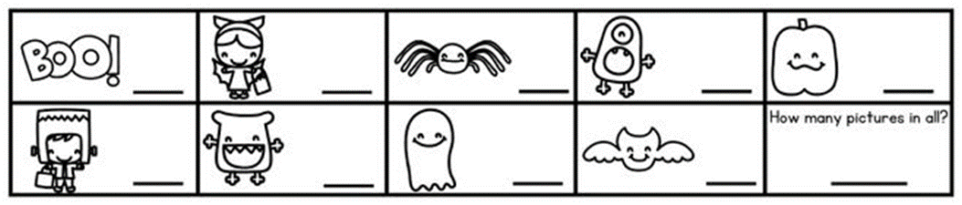

brown

yelloww

purple

grey

green

red

pinkink

blue

orange

yelloww

blue

pinkink

pinkink

blue

green

orange

red

**black**

brown

brown

green

blue

green

**black**

blue

purple

brown

grey

yelloww

red

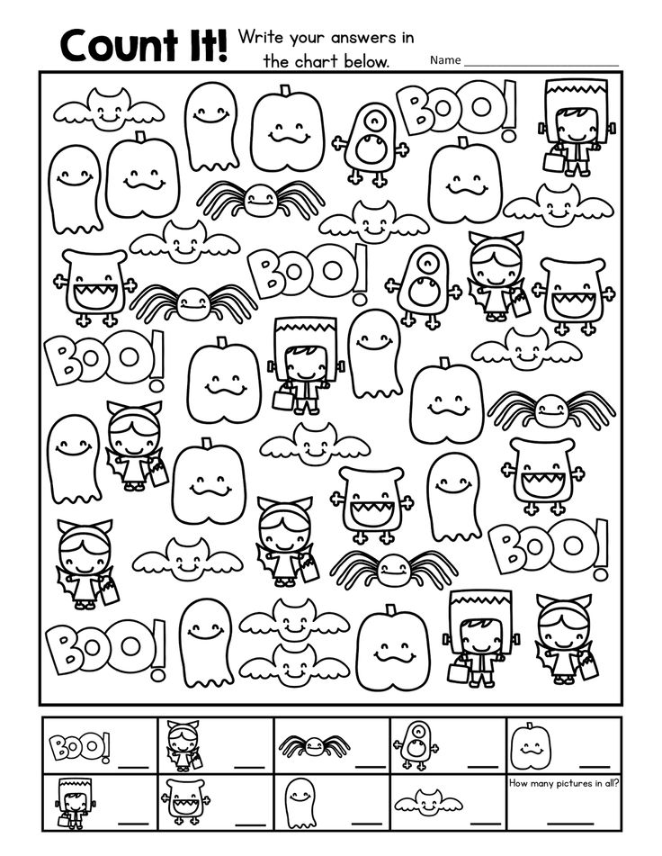

purple

**black**

orange

yelloww

pinkink

red

red

violet

**black**

violet

grey

green

pinkink

yelloww

orange

red

blue

purple

violet

orange

green

blue

pinkink

**black**

yelloww

violet

orange

grey

brown

purple

green

blue

pinkink

red