Задание для контроля навыков чтения
«A ball point pen»
Тема: «Научно-технический прогресс»
УМК «English 10-11» (Кузовлев В.П. и др.)
Панова Ирина Леонидовна – учитель английского языка
МБОУ «СОШ №14 пос.Подъяпольское»
Шкотовского района Приморского края

A ball point pen is a pen that uses a small rotating ball made of brass¹, steel, or tungsten carbide² to disperse ink as you write. All of the pens that preceded the ballpoint -- whether quill³, metal or fountain -- used a watery, dark india ink that fed through the pen using capillary action. The problems with this technology include:
- The ink can flow unevenly⁴. - The ink dries slowly. - The ink is exposed⁵ to the air while it is flowing through the pen, so it cannot dry quickly or it would clog⁶ the pen. When it does accidentally dry in the pen, the ink gums the whole thing up and requires meticulous⁷ cleaning.
When you add to this list the fact that fountain pens tend to flood when you fly on an airplane with them, you can see that all pens up until World War II presented some significant problems for their users -- the world awaited a better solution!
The goal of a ball point pen is to create a device that can distribute a fast-drying thick ink, without having the ink dry out in the pen itself. The key is the ball. The ball acts as:
- A continuous cap that keeps the ink from drying
- A mechanism for getting the ink onto the paper
The ball is located in between the ink reservoir and the paper by a socket⁸ and while it's in tight, it has enough room to roll around as you write. As the pen moves across the paper, the ball turns and gravity forces the ink down the reservoir and onto the ball where it is transferred onto the paper. This rolling mechanism allows the ink to flow onto the top of the ball and roll onto the paper you're writing on, while at the same time sealing⁹ the ink from the air so it does not dry in the reservoir.
Because the tip of a normal ballpoint pen is so tiny, it is hard to visualize how the ball and socket actually work. One way to understand it clearly is to look at a bottle of roll-on anti-perspirant, which uses the same technology at a much larger scale! The typical container of roll-on has the same problems a ballpoint pen does -- it wants to keep air out of the liquid anti-perspirant while at the same time making it easy to apply.
If you look inside the container, what you have is extremely simple -- the ball is exposed so it can pick up the liquid anti-perspirant.
A ballpoint pen works exactly the same way. The tiny ball is held in a socket, and the back of the ball is exposed so it can pick up ink from the reservoir. The ball fits into the socket with just enough space to move freely.
1 латунь; 2 карбид вольфрама; 3 перо 4 неравномерно; 5 а) подвергается воздействию;
б) установлен; 6 засоряться; 7 тщательный; 8 разъем/зажим; 9 запечатывая

A) B) C)
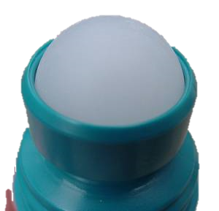
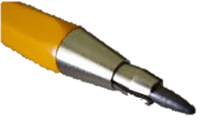
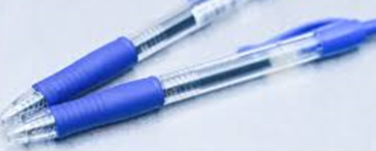
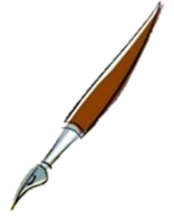
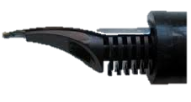
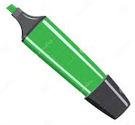 D) E) F)

Task №1: What is the text about? Choose a picture.
Task №2: Which things are written about? Choose pictures.
Task №3: What were the problems with pre-ball point pens?
Task №4: Why is a roll-on anti-perspirant exposed here?
Task №5: What are the parts of a ball point pen?
Task №6: How does a ball point pen work?
*Task №7: Why did Soviet/Russian cosmonauts write wax pencils in the space?

Ccылка:
http://science.howstuffworks.com/innovation/science-questions/question683.htm

